Getting IntelliJ installed
A Special Note About IntelliJ and Java:
As of fall 2018, Oracle has ended support for JDK 9 and 10, and this course has not yet been tested against later JDK versions. Instead, we’re going to install JDK 8. Therefore, please click the link in Step 1 instead of Googling “JDK”.

If you already have some version of JDK installed on your computer, you are welcome to jump straight to Step 3 that asks you to download and install IntelliJ. However, if you encounter errors, please jump back to Step 1 and install JDK 8.

- First, before installing IntelliJ, we need to get Java installed. Go to https://web.cs.wpi.edu/~jmcuneo/jdk/. Click the appropriate .exe file (Windows) or .dmg file (Mac) in the list to download it.

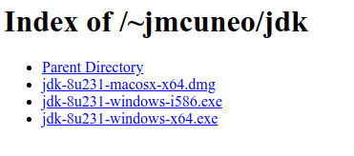
NOTE: If you are installing on Windows, choose i586 for 32-bit systems or x64 for 64-bit
systems. Unless your computer is very old, you’re probably on a 64-bit system.

- Double-click the file to run it. It will take you through an installation wizard, where you can keep all of the defaults. Ignore any messages about a roadmap. Click “Close” when the installation is complete.

- Navigate to https://www.jetbrains.com/idea/download/ and download IntelliJ for your operating system. You only need the community edition for this course, but you can use your WPI email to download the Ultimate edition if you prefer (it’s free for WPI students).

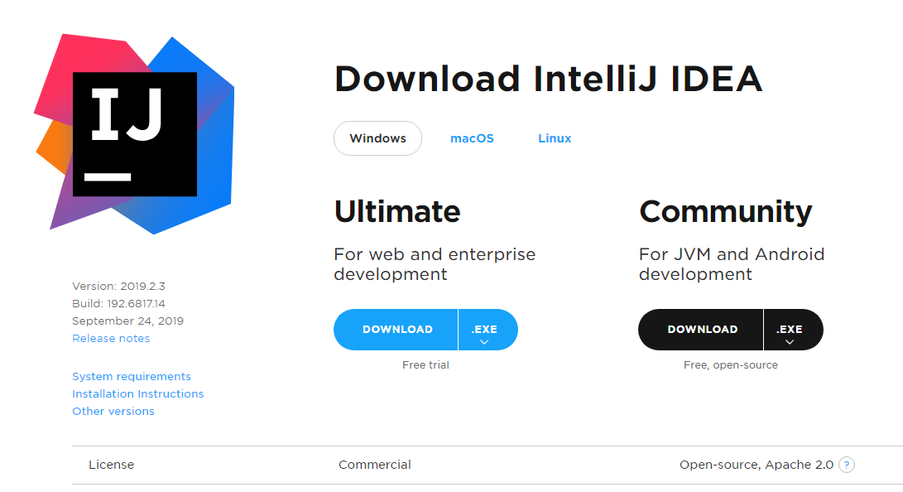

- That should download an installation file. Double-click the file to run it. You may choose any customization options you like, but you’ll be fine if you accept all of the defaults.

- Open IntelliJ. If you are prompted with an “Import IntelliJ IDEA Settings From…” window, select “Do not import settings”. Accept the Privacy Policy, and do not send Usage Statistics.

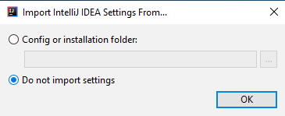

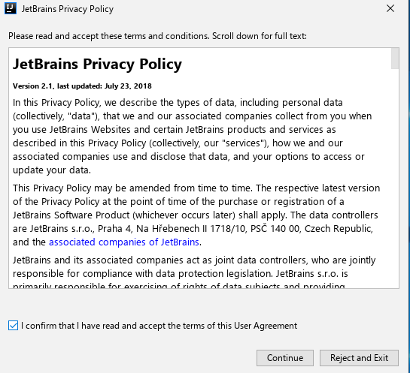

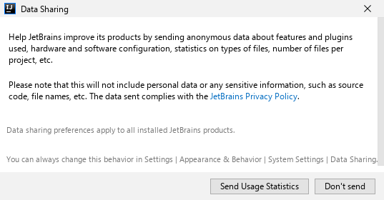

- You will then be prompted for your UI theme. Choose whichever theme you prefer (you can always change it later) and hit Next.

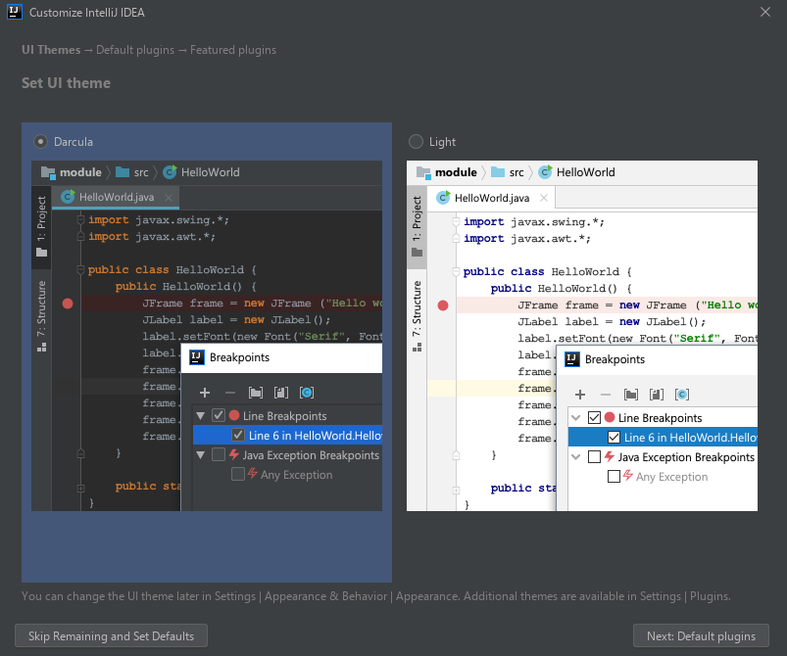

- On the Default Plugins screen, we recommend disabling all of your plugins except for Test Tools. This will give you faster performance. Click Skip Remaining and Set Defaults when you’re done.

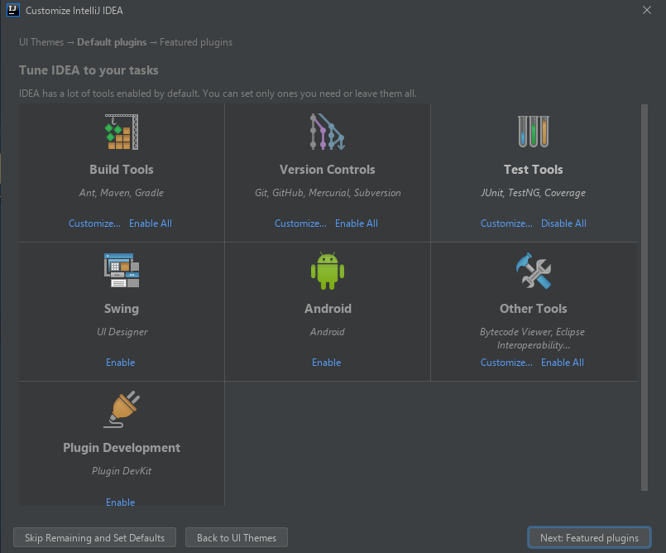

- Optional: IntelliJ (like most IDEs) has keyboard shortcuts that make common tasks easier to perform. Mastering these shortcuts will make you a quicker developer. A quick Google search will give you an extensive list of the ones available.

Creating a new Java project
For this class, you will create a new Java project for every assignment. This includes homeworks and labs. These instructions will walk you through that process.

- When IntelliJ starts, you’ll be greeted by an interface that will have options to ‘Create new project’, ‘Import project’, etc. Select ‘Create new project’.

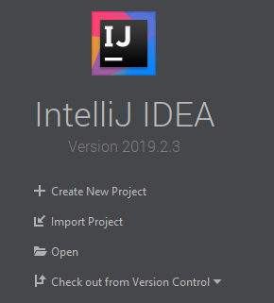

- There are a couple of things to note on this next page. First, make sure Java is selected in the upper left. Also, make sure that the top dropdown, labeled “Project SDK”, has 1.8 selected. This 1.8 is saying that you are using the Java 8 Development Kit.

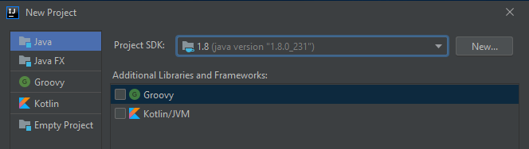

If you do not have 1.8 as an option, go back to Step 1 and install JDK 8. You can then go back to the dropdown and hit New and navigate to the folder where it installed. This folder location differs between operating systems. The location will probably look something like the following:

Windows: C:\Program Files\Java\jdk1.8.0_231
OS X: /Library/Java/JavaVirtualMachines/jdk1.8.0_231.jdk

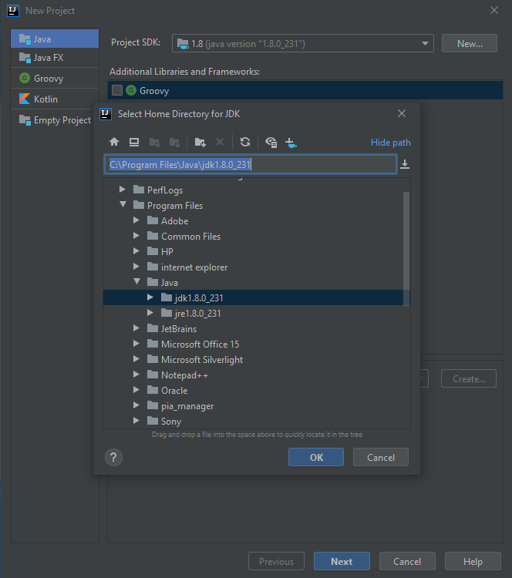

- After you’re sure you have Java selected and 1.8 is in the dropdown, hit Next at the bottom. You can ignore the screen that talks about templates. Hit Next again.

- On the next screen you will be able to name your project and decide on a location for where the project will be stored on your computer. We recommend that you create a new directory on your computer for all of your CS2102 work and put all of your projects in that directory. Once you’re happy here, hit Finished and IntelliJ will open your new project!

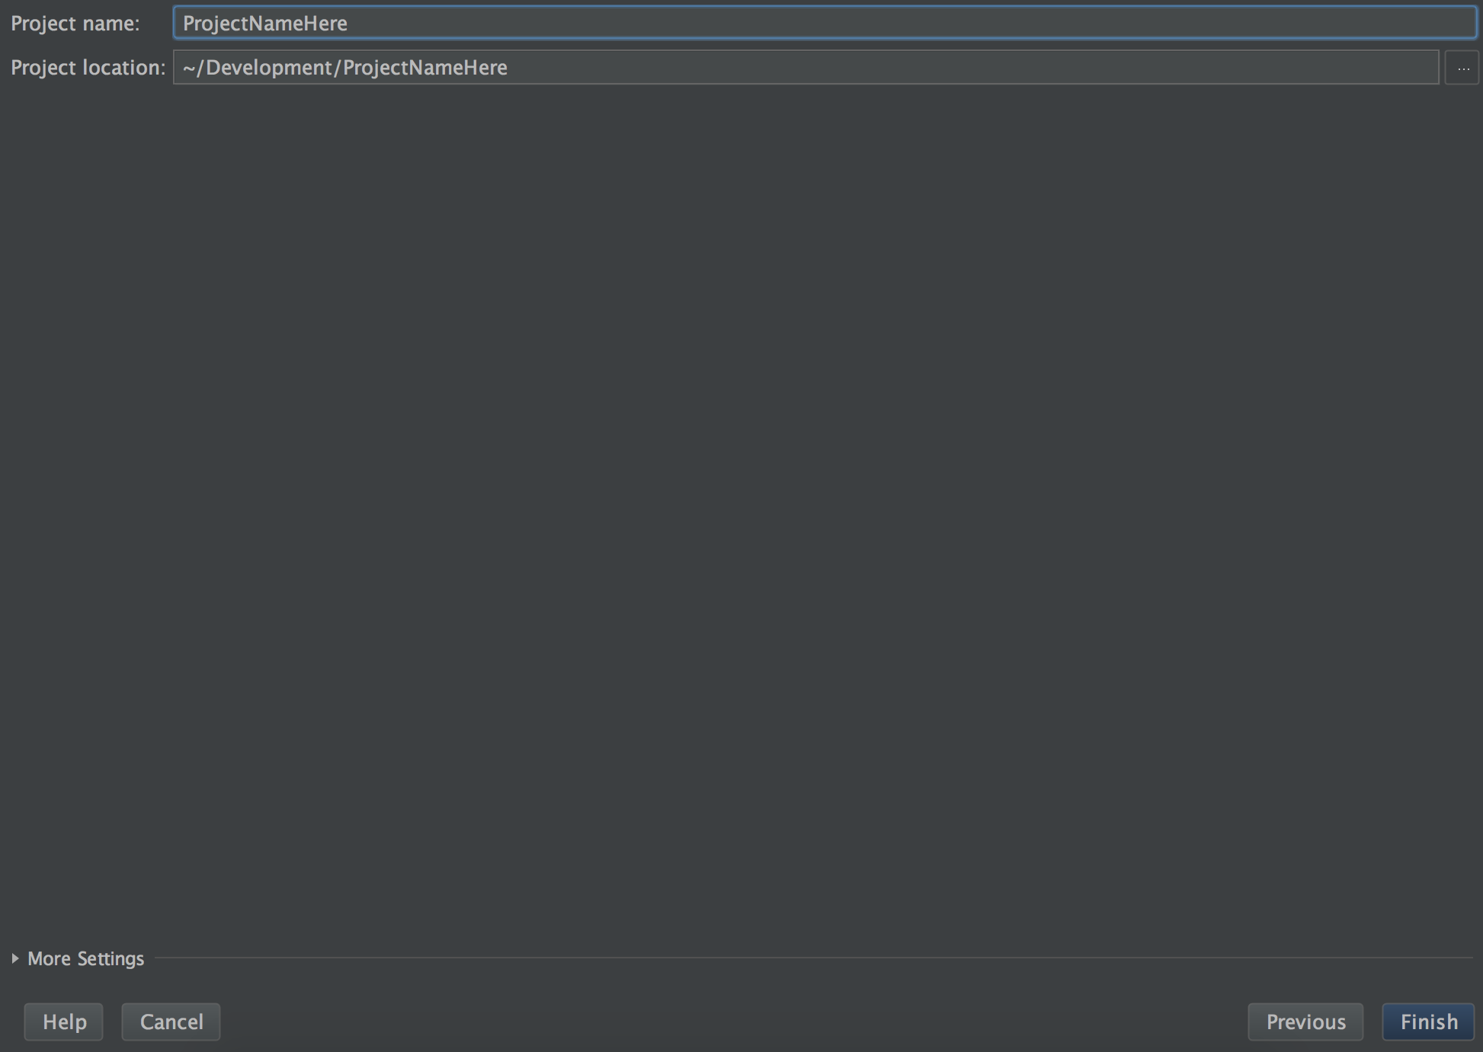

Creating new classes, interfaces, etc.
- When your project opens, you’ll be greeted by a top toolbar and two main panels. The one on the left is your project navigation panel and the bigger one on the right will be where you write your code. When you first create the project, there will be no code file open and the right panel will look like it does in the screenshot.

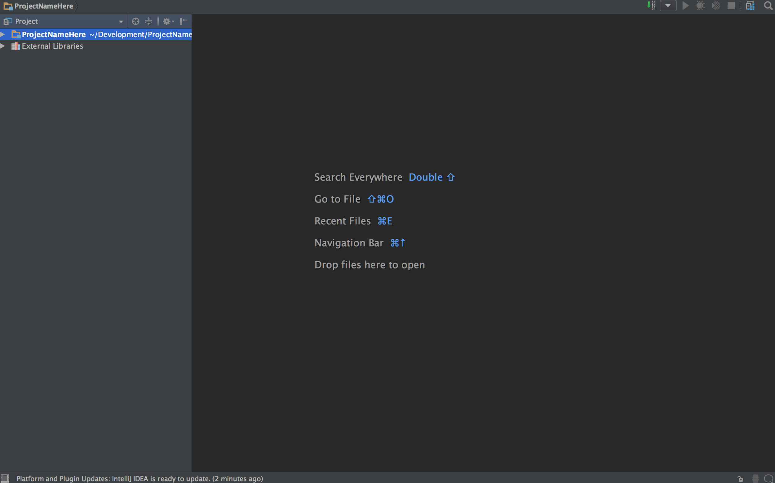

Note: If you do not see the left-hand navigation panel, click the project folder icon on the left side.

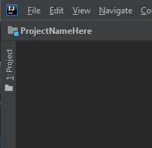

- For everything we will do in this class, we’ll keep our code files in a src folder. In order to see this folder, you can click the small triangle to the left of the project name in the project navigation panel.

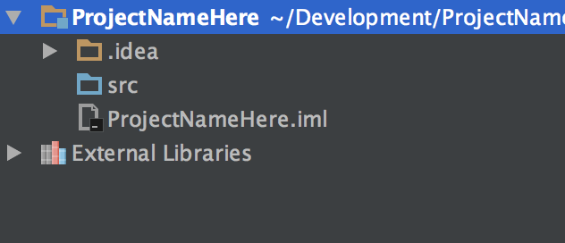

- In order to create a new Java class, interface, or any other file, you can right click the src folder and hover over New. You will see a number of choices. The one that we’re particularly interested in is Java Class. This may seem weird but selecting Java Class will give us the ability to create Classes, Interfaces, and more. Go ahead and select New Java Class.

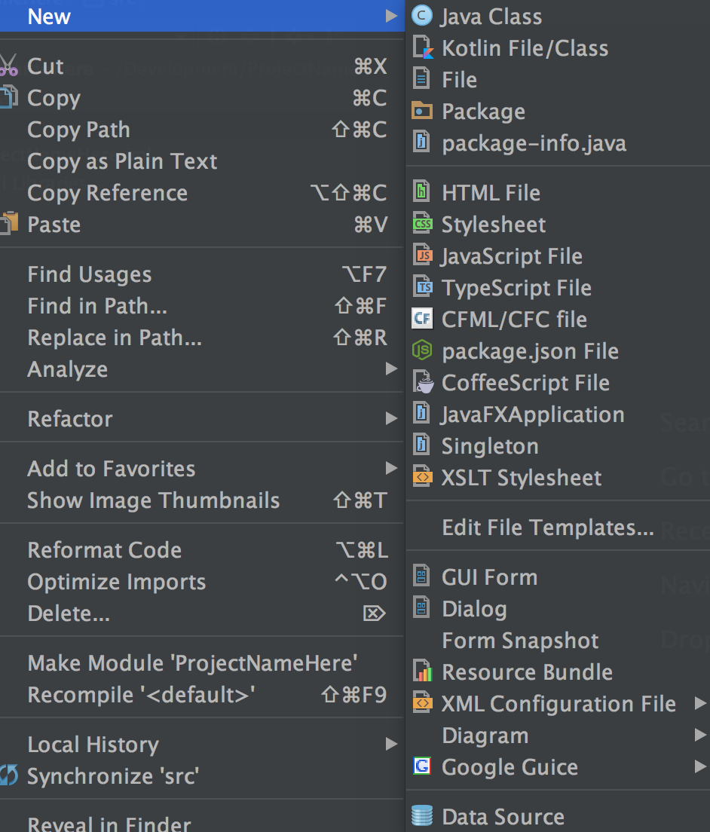

- Here we will name the Class and choose its type. This dropdown is where you can specify whether this is to be a Class or Interface, etc.

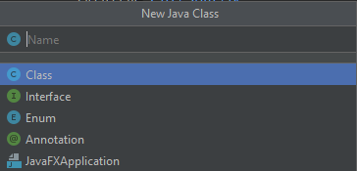

- Once you’re happy with the Name and Kind, you can click OK. Remember, it’s very important that your code is in the default package (src) here. You’ll also notice that
IntelliJ opened our new Java file in the large area in the right.

Setting up JUnit
- JUnit is a popular testing library. It is widely used within industry and the rest of the Java community, and it comes bundled with IntelliJ. To use it, let’s make a test class to hold all of our tests. We will call this class Examples in all of our projects. In order to create this, right click the project in the project navigator and click New -> Java Class.

- At the top of your class, add the following import statements:

import org.junit.*;
import static org.junit.Assert.*;

- This might produce an error. If so, hover over one of the import statements and then select Add 'JUnit4' to classpath.

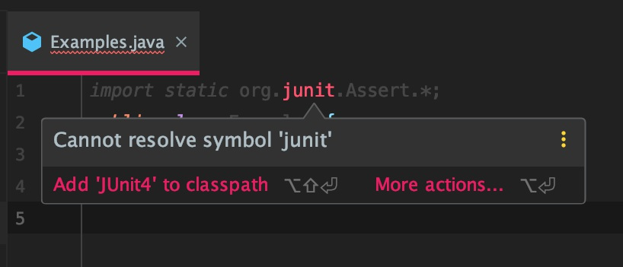

- In the class body you can create a sample test method:

@Test
public static void test() {
fail(“Not yet implemented”);
}

- To run the test, click the icon in the sidebar next to the method name or the class name, and then choose either `Run test()` or `Run Examples`. You can also select the Play icon in the upper right-hand corner.

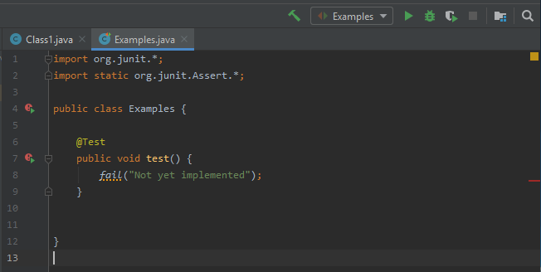

NOTE: The first time you run your tests, the icons on the left may look a little different than shown in the image.

- A new panel should appear at the bottom of the editor window. This shows a summary of your tests. It shows you how many tests were run, which results in errors, and which resulted in failed tests. The goal is for it to run all the tests with no errors and no failed tests. If that happens, you will see all green checkmarks.

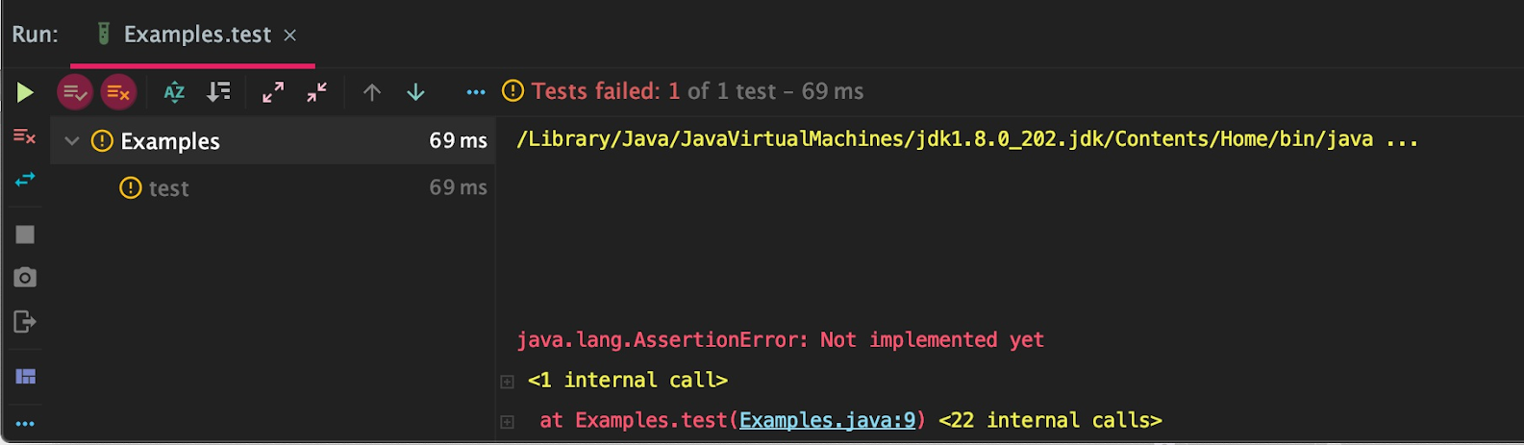

Creating Test Cases
- Now that you have your project set up, you can get to work. If you write test cases before you implement your methods, it can make it easier to write the implementation. You’re not required to program in any specific order, but regardless of whether you start with or end with test cases, you’ll have to write some. For this, we will use JUnit, which is an industrial standard used mainly for Unit Testing.

- In your Examples class, you should have your imports and a dummy test case. Every test case will follow this pattern. The @Test annotation tells the compiler that the next method is a test case and should be treated as such. After that annotation, you’ll have a method with some assert statement in it. For now, we will only be using assertEquals but know that there are other ones such as assertNotEquals and more.

- assertEquals takes in two or three arguments, depending on if you’re comparing doubles/floats or not. The first two parameters are the two things to compare. The third parameter is only used when those first two things are doubles or floats. The third parameter is a tolerance. For example, if your two values are 1.00049 and 1.0005, you would typically like these to be equal. This is where the tolerance comes in. If you use 0.001 as the third parameter, it will compare the two values up to the thousandths place.

- Here is the dummy test code for reference again:

@Test
public static void test() {
fail(“Not yet implemented”);
}

- We can replace the fail line with an assertEquals to create a legitimate test case.

- You can add as many tests as you need or want in your Examples class as long as they all follow this pattern.

